Task electrical engineering :

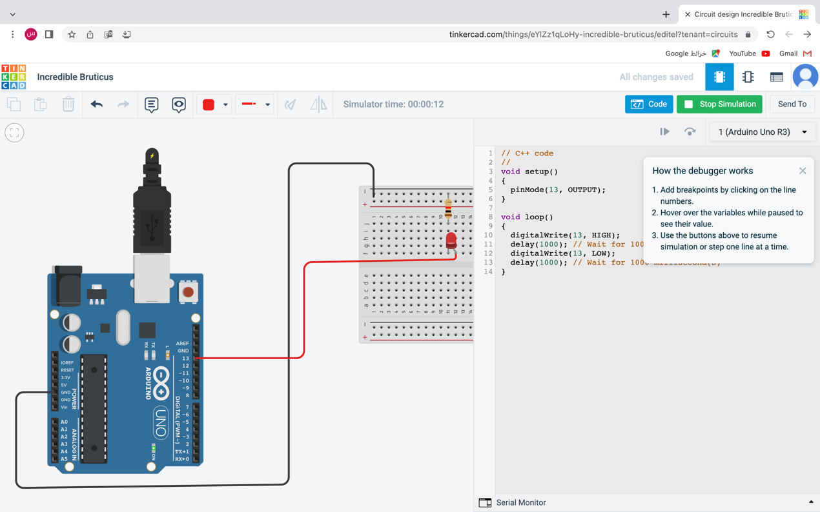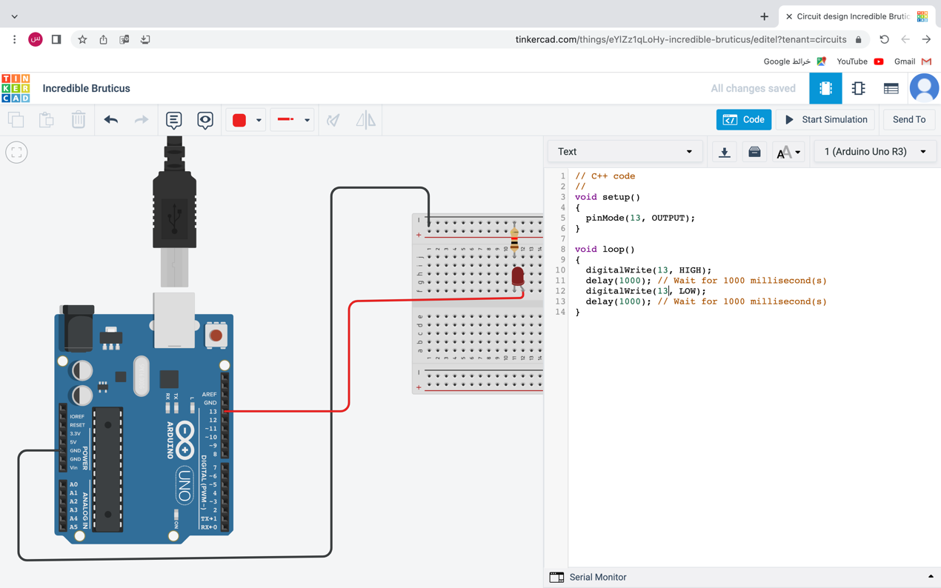

<https://www.tinkercad.com/things/eYlZz1qLoHy-incredible-bruticus/editel?sharecode=fYQ7L16Xra-DOmfXq-JAe3XM00k0rZx9EaR9dX7TKE0>